Bawtry Mayflower Primary School

Personal, Social and Health Education (PSHE) and Citizenship and Sex and Relationship Education (SRE) Policy
At Bawtry Mayflower Primary School, we are committed to developing the whole child. Personal, Social and Health Education (PSHE.) Citizenship and Sex and Relationship Education (SRE) gives pupils the knowledge, skills and understanding they need to lead confident, healthy, independent lives, establish and maintain positive relationships and become informed, active, responsible citizens.
Aims
PSHCE and SRE enables the children to:
- Stay healthy.
- Keep themselves and others safe.
- Have worthwhile and fulfilling relationships.
- Respect the differences between people.
- Develop independence and responsibility.
- Make the most of their own abilities and those of others.
- Behave in a socially and morally acceptable way towards authority and each other.
- Become involved in the life of their community.
- Know about equality and how to be an active citizen.
- Know about economic wellbeing.
- Explore, consider and begin to understand moral dilemmas.
- Learn the value of respect, love and care.
- Question and discuss physical development without embarrassment.
PSHE and Citizenship Curriculum
Bawtry Mayflower Primary School believe that it is important that opportunities exist throughout the curriculum to promote pupils’ personal, social and emotional development. Provision for PSHE and Citizenship will be through a combination of:

- Learning Powers
- Circle time and story times in the Early Years, KS1 and KS2
- Planned aspects of science
- Planned aspects of the computing curriculum
- Assembly time
- World news
- Opportunities in other curriculum subjects
- School Nursing involvement
- Whole school timetabled activities (such as assemblies and themed week’s e.g. Anti-bullying week)
- Half termly topics
- Involving pupils in the life of the school and wider community (such as Pupil Voice and fund raising events)

Learning Powers
Staff and children at Bawtry Mayflower worked together to develop our Learning Powers:
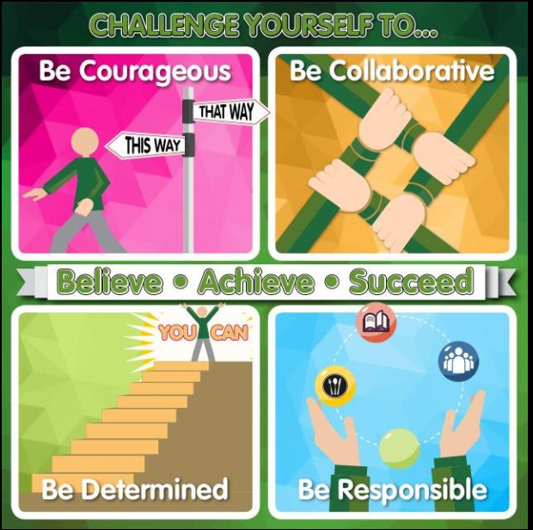

Be Determined
Be Collaborative
Be Courageous
Be Responsible

Our Learning Powers are embedded throughout the whole school. They are used to support children to become independent responsible learners in all aspects of the curriculum and to prepare them to become citizens of the modern world.

Access to the curriculum
All children have equal access to the PSHE and citizenship curriculum, including Sex and Relationship Education, regardless of their ability, ethnic group, gender or social background. Teaching methods will be determined by class teachers and will ensure access by all children in every activity. Children, who may have special needs, will be supported by the class teacher, support staff and, if necessary, the Special Needs Coordinator (SENDCO).

Confidentiality
Class Teachers and Teaching Assistants conduct all lessons in a sensitive manner. Class ground rules are established during all lessons and activities to ensure children feel safe & are willing to explore sensitive issues. Staff are always available to discuss issues with any parents. Children’s questions are answered as honestly and fully as appropriate. However, if a child makes reference to anything which gives cause for concern staff will report concerns to the Head teacher/DSL who will decide whether the matter should be dealt with as a child protection issue.

Sex and Relationship Education

What is SRE?
Sex and relationships education (SRE) is learning about sex, sexuality, emotions, relationships, sexual health and ourselves. It is an integral part of the lifelong learning process, beginning in early childhood and continuing throughout adult life.

The focus will be on healthy, respectful relationships in the real world and online. The key areas of learning will be:
• Families and people who care for me
• Caring friendships
• Respectful relationships
• Online relationships
• Being safe

How SRE will be delivered
SRE is delivered in both Science and PSHE lessons predominantly by the pupil’s class teacher in mixed gender groupings. The effective teaching of SRE is supported through the School Nursing Service in Years 5 and 6 and The Big Talk from Reception to year 6.
• Sex education will be developmental and age appropriate.
• Pupils will be taught about the nature of the human body and how it grows and changes.
• Sex education will be taught within the context of relationships and family life.

Working in Partnership with Parents
Parents are the key people in:
- Teaching their children about sex and relationships;
- Maintaining the culture and ethos of the family;
- Helping their children cope with the emotional and physical aspects of growing up.
- Preparing them for the challenges and responsibilities that sexual maturity brings.

The school is committed to working with parent and carers and informs parents by letter when pupils will be studying SRE.

Parents and carers right to withdraw
Parents have the right to withdraw their child from SRE education lessons.
- Once a child has been withdrawn they cannot take part in the SRE programme until the request for withdrawal has been removed.
- Materials should be made available to parents/carers who wish to supplement the school SRE programme or who wish to deliver SRE to their children at home.

Safeguarding and Child Protection
We recognise that because effective SRE may alert children to what is appropriate and inappropriate sexual behaviour, there is an increased possibility that a disclosure relating to abuse may be made. All staff are aware of the Safeguarding and Child Protection procedures and will report the disclosure to the DSL immediately.
Sexually Active Pupils:
There are extremely rare occasions when a primary-aged child, who is sexually active or contemplating sexual activity, approaches an adult. If this occurs, it will be viewed as a child protection issue. The designated member of staff will follow Safeguarding and Child Protection Procedures and seek advice from the relevant agency.

January 2019

