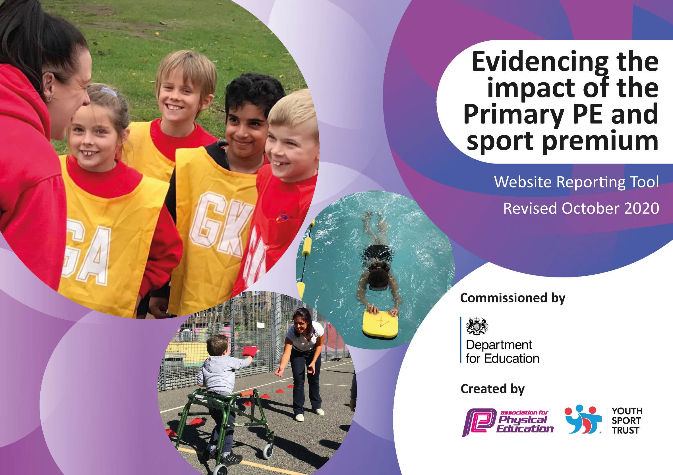

Schools must use the funding to make additional and sustainable improvements to the quality of PE and sport they offer. This means that you should use the Primary PE and Sport Premium to:

- develop or add to the PE and sport activities that your school already offers
- build capacity and capability within the school to ensure that improvements made now will benefit pupils joining the school in future years

Please visit gov.uk for the revised DfE guidance including the 5 key indicators across which schools should demonstrate an improvement. This document will help you to review your provision and to report your spend. DfE encourages schools to use this template as an effective way of meeting the reporting requirements of the Primary PE and Sport Premium.

We recommend you start by reflecting on the impact of current provision and reviewing the previous spend.
Under the Ofsted Schools Inspection Framework, inspectors will assess how effectively leaders use
the Primary PE and Sport Premium and measure its impact on outcomes for pupils, and how effectively governors hold them to account
for this.

Schools are required to publish details of how they spend this funding as well as on the impact it has on pupils’ PE
and sport participation and attainment.
We recommend regularly updating the table and
publishing it on your website as evidence
of your ongoing review into how you are using the money
to secure maximum, sustainable impact. To see an example of how to complete the table please click HERE.
Swimming Data
Please report on your Swimming Data below.

Meeting national curriculum requirements for swimming and water safety. | Due to school and leisure facility closures, 0% of children in the current year 6 cohort have met the national curriculum requirements for swimming and water safety.
What percentage of your current Year 6 cohort swim competently, confidently and proficiently over a distance of at least 25 metres? | 0 %
What percentage of your current Year 6 cohort use a range of strokes effectively [for example, front crawl, backstroke and breaststroke]? | 0 %
What percentage of your current Year 6 cohort perform safe self-rescue in different water-based situations? | 0 %
Schools can choose to use the Primary PE and sport premium to provide additional provision for swimming but this must be for activity over and above the national curriculum requirements. Have you used it in this way? | Yes/No

Action Plan and Budget Tracking
Capture your intended annual spend against the 5 key indicators. Clarify the success criteria and evidence of impact that you intend to measure to evaluate for students today and for the future.

Academic Year: 2020 - 2021 | Total fund allocated: £18,240
Key indicator 1: The engagement of all pupils in regular physical activity – Chief Medical Officers guidelines recommend that primary school pupils undertake at least 30 minutes of physical activity a day in school |  |  |  | Percentage of total allocation:
 |  |  |  | 54%
Intent | Implementation | Funding allocated: | Impact | Sustainability and suggested next steps:
Introduce scoot to school in order to get more pupils travelling to school under their own steam rather than being dropped off in a car – Spring / Summer Initiative  Improve children’s activity levels to and from school and their road safety skills – Spring / Summer Initiative  Further promote physical activity at break times and lunch times.  Use outdoor spaces to promote outdoor play, and staff given training and resources to engage pupils in play based activity.  All pupils to be included within lessons. | - Purchase 30 scooters to introduce scooting in school.  - Run scooter workshops.  - Book bikeability training level 1 and 2 for children in KS2.  - Sign up to Big Pedal 2021.  - Road Safety Training.  - Purchase playground equipment for each class bubble.  - Purchase fixed playground equipment – new trim trail for KS1 / astro turf for KS2  - Kit policy to be in place.  - Spare PE kit to be purchased – indoor and outdoor. | £1000  £600  £8,000  £300 | Due to school closures, the impact of actions could not be evaluated as planned.  Y4 teachers led road safety training in class.  All children able to take part in a range of physical activities at break times and lunch times.  Children using outdoor equipment more during break and lunch.  Quotes received.  Increased participation due to children coming to school in their P.E kits = 100% participation | Implement actions in the next academic year.  Equipment being used effectively and correctly. Purchasing additional equipment will support future high quality teaching should budget be reduced.  Audit of equipment to be completed during the Autumn term.  Training for year 5 play leaders.  Purchase fixed playground equipment to promote outdoor play.  Children to continue to come to school in their P.E kits to ensure all children are included in lessons.
Key indicator 2: The profile of PESSPA being raised across the school as a tool for whole school improvement |  |  |  | Percentage of total allocation:
 |  |  |  | 4%
Intent | Implementation | Funding allocated: | Impact | Sustainability and suggested next steps:
Class celebration assembly every half term to ensure the whole school is aware of the importance of PE and Sport and to encourage all pupils to aspire to being involved in the assemblies.  Raise the profile of PE and Sport for all visitors and parents.  Role models – local sporting personalities to attend assemblies / put on events so that pupils can identify with success and aspire to be a local sporting hero – Spring / Summer 2021 | - Achievements celebrated in assemblies.  - Different classes to do different sporting displays.  - Outside school sporting achievements to be reported weekly on the newsletter / on the blog.  - Ascertain with local personalities the pupils relate to and invite them into school.  - Invite athletes into school – linked to world events, e.g. Olympics, world cup.  - Purchase non-fiction books about sporting heroes and women in sport. | £150  £600  £100 | Due to school closures, the impact of actions could not be evaluated as planned.  Children’s achievements celebrated with peers, staff and parents via the blog.  Covid restrictions. | Implement actions in the next academic year.  Continue to celebrate the outside school sporting achievements of pupils in order to raise the profile of sport.  Continue to add to this collection in order to inspire children.

Key indicator 3: Increased confidence, knowledge and skills of all staff in teaching PE and sport |  |  |  | Percentage of total allocation:
 |  |  |  | 19%
Intent | Implementation | Funding allocated: | Impact | Sustainability and suggested  next steps:
In order to improve progress and achievement of all pupils the focus is on up-skilling the staff.  This could be via TEAMs. | - Identify the local centers that are running these courses.  - Ensure all identified staff are enrolled.  - Establish dates when cover is required and arrange cover staff.  - Ensure that time is provided for school based working. | £3500 | Due to school closures, the impact of actions could not be evaluated as planned. | Implement actions in the next academic year.  Registered to SPR JNRS to aid up skilling of staff in the next academic year.
Key indicator 4: Broader experience of a range of sports and activities offered to all pupils |  |  |  | Percentage of total allocation:
 |  |  |  | 11%
Intent | Implementation | Funding allocated: | Impact | Sustainability and suggested  next steps:
Continue to offer a wider range of activities both within and outside the curriculum in order to get more pupils involved.  e.g. change4life club  To champion ‘new sports’ in the school (linked to ‘sport in the news’ where possible) | - Involve external coaches to work with children in after school clubs Summer 2021  - Purchase equipment to enable pupils to access a wider range of activities.  - Children will have the opportunity to engage with at least 1 ‘new sport’ (in addition to those core sports provided) each academic year. | £2000 | Due to school closures, the impact of actions could not be evaluated as planned. | Implement actions in the next academic year.  In the next academic year, offer a wider range of activities outside the curriculum in order to get more pupils involved.
Key indicator 5: Increased participation in competitive sport |  |  |  | Percentage of total allocation:
 |  |  |  | 1%
Intent | Implementation | Funding allocated: | Impact | Sustainability and suggested  next steps:
Provide regular opportunities for intra and inter school competition.  To introduce additional competitive sports identified by pupils in recent survey in order to engage more pupils.  Engage more girls in inter/intra school teams.  Regular opportunities in PE lessons for children to compete against one another. | - Arrange friendly competition – inter / intra school when possible to do so.  - Attend school games competitions when possible to do so.  - Obtain external recognition for the quality of sport provision at BMPS – school games mark. | £275 | Due to school closures, the impact of actions could not be evaluated as planned. | Implement actions in the next academic year.

Key indicator 6: Ensure the effective delivery of remote teaching and learning in Physical Education |  |  |  | Percentage of total allocation:
 |  |  |  | 0%
Intent | Implementation | Funding allocated: | Impact | Sustainability and suggested  next steps:
Audit activities put on TEAMs to ensure that the children are receiving a wide range of opportunities.  Check remote learning against policy.  Monitor engagement of all children including SEND and PP.  Support staff – compose a list of useful websites. | - Staff to be aware of and use the following resources:  - Joe Wicks – ‘The Body Coach’.  - Cosmic Yoga  - Change4Life Website  - Go Noodle  - BBC super movers  - WOW active challenge cards |  | School provided remote physical education, this ensured that all children had the opportunity to participate in physical activity during partial school closure.  Online PE resources, which enhanced pupil engagement and complemented the schools’ own resources, were identified to ensure that children stayed fit and active. | Continue to provide remote education, aligned as closely as possible with in-school provision, for those children who are isolating.  Continue to identify online resources which enhanced pupil engagement.
Key indicator 7: Increased health and well-being of our children with the understanding that a healthy mind = a healthy body. |  |  |  | Percentage of total allocation:
 |  |  |  | 11%
Intent | Implementation | Funding allocated: | Impact | Sustainability and suggested  next steps:
Increased understanding of the importance of health and wellbeing and how this can have a positive impact on our pupils’ learning. | - Purchase Jigsaw Health and Well-Being scheme  - Staff CPD | £2000 | Pertinent and relevant to the children’s learning.  Activities based around the children’s mental well-being.  Children have discussed a wide range of topics, including friendships and good mental health.  Increased understanding of children’s own health and wellbeing. | Continue to embed Jigsaw in the new academic year using the scheme.  SH to use the Jigsaw launch materials to introduce each half term Jigsaw piece/theme.

Summary of Primary Sport Premium 2021 – 2022

Key barriers 2021-2022

• Poverty reducing children’s participation in extracurricular activities and competitive opportunities.
• Improving outcomes due to lack of participation outside of school.
• Many children have had prolonged periods of inactivity since March 2020, reducing mental wellbeing, fitness, communication and physical skills.

Objectives of Spend

• Develop further the provision and quality of PE & School Sport at Bawtry Mayflower Primary School. Ensure that PE & School Sport is judged as at least good by any external monitoring that may take place.
• Increase opportunities for participation in extra-curricular clubs and inter and intra school competitions.
• Broaden the sporting opportunities and experiences available to pupils.
• To further develop a love of sport and physical activity.
• To support children as part of the recovery curriculum in school following Covid 19 and the restrictions that required be put in place.
• Further develop additional CPD and training for staff in P.E.

Things to consider:
Employment and deployment of specialist PE LSA – Objective - Team teach with each year group every week, supporting class teacher in delivering to each child 2 hours of quality teaching. Support in developing further inter school competitions, support in preparing children for competitions, attending competitions and further extending the number of extra-curricular school clubs the school can offer. Run focused lunchtime clubs with a view to ensuring all are active and improving the fitness of children

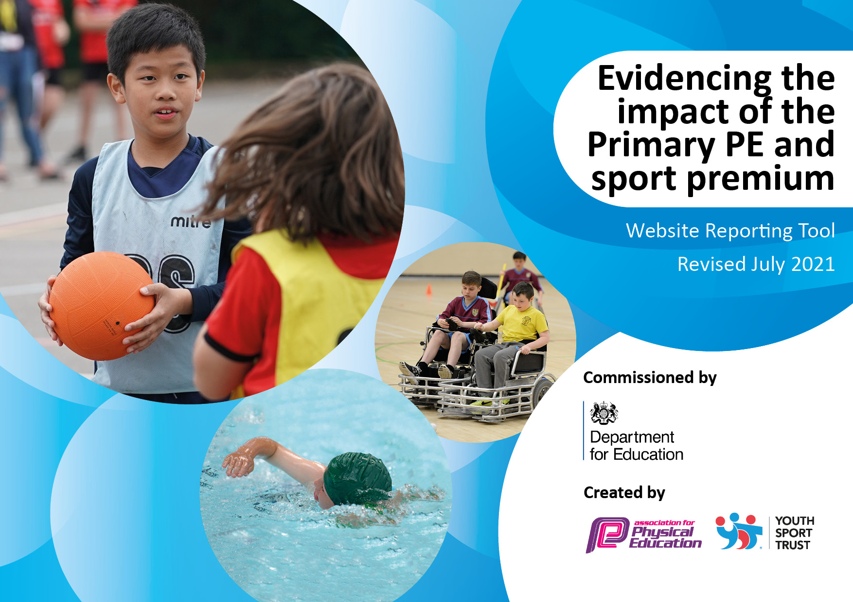

Academic Year: 2021-2022 | Total fund allocated:
Key indicator 1: The engagement of all pupils in regular physical activity – Chief Medical Officers guidelines recommend that primary school pupils undertake at least 30 minutes of physical activity a day in school |  |  |  | Percentage of total allocation:
Intent | Implementation | Funding allocated: | Impact | Sustainability and suggested next steps:
Introduce scoot to school in order to get more pupils travelling to school under their own steam rather than being dropped off in a car – Spring / Summer Initiative  Improve children’s activity levels to and from school and their road safety skills – Spring / Summer Initiative  Further promote physical activity at break times and lunch times.  Use outdoor spaces to promote outdoor play, and staff given training and resources to engage pupils in play based activity. | - Purchase 30 scooters to introduce scooting in school.  - Run scooter workshops.  - Book bikeability training level 1 and 2 for children in KS2.  - Sign up to Big Pedal 2022.  - Road Safety Training.  - Purchase playground equipment for each class bubble.  - Train Playground Leaders  - Purchase fixed playground equipment. | £1000  £600  £8,000
Key indicator 2: The profile of PESSPA being raised across the school as a tool for whole school improvement |  |  |  | Percentage of total allocation:
Intent | Implementation | Funding allocated: | Impact | Sustainability and suggested next steps:
Class celebration assembly every half term to ensure the whole school is aware of the importance of PE and Sport and to encourage all pupils to aspire to being involved in the assemblies.  Raise the profile of PE and Sport for all visitors and parents.  Role models – local sporting personalities to attend assemblies / put on events so that pupils can identify with success and aspire to be a local sporting hero – Spring / Summer 2021  Playground Leaders program to be implemented and Year 5/6 pupils trained.  Provide equipment for effective PE provision to take place. | - Achievements celebrated in assemblies.  - Different classes to do different sporting displays.  - Outside school sporting achievements to be reported weekly on the newsletter / on the blog.  - Ascertain with local personalities the pupils relate to and invite them into school.  - Invite athletes into school – linked to world events, e.g. Olympics, world cup.  - Purchase non-fiction books about sporting heroes and women in sport.  Children to apply for Playground Leaders program. Children to take a lead role during dinner time. Playground Leaders to be responsible for ordering dinnertime equipment, team days and intra-school competitions (suported by PE Lead).  Purchasing of additional equipment in line with needs of children and staff. | £150  £600  £100  £500  £1500

Key indicator 3: Increased confidence, knowledge and skills of all staff in teaching PE and sport |  |  |  | Percentage of total allocation:
Intent | Implementation | Funding allocated: | Impact | Sustainability and suggested  next steps:
In order to improve progress and achievement of all pupils the focus is on up-skilling the staff.  This could be via TEAMs.  Professional Development opportunities For teachers in PE and sport  Qualified sports coaches to Work with primary teachers When teaching PE | - Identify the local centers that are running these courses.  - Ensure all identified staff are enrolled.  - Establish dates when cover is required and arrange cover staff.  - Ensure that time is provided for school based working.  - Register to SPR JNRS  Deliver a ‘teacher support program’ based on developing skills and progression across a range of physical activities. There is a lasting legacy of teacher development that leads to greater teacher confidence and greater outcomes of children. | £3500  £2500
Key indicator 4: Broader experience of a range of sports and activities offered to all pupils |  |  |  | Percentage of total allocation:
Intent | Implementation | Funding allocated: | Impact | Sustainability and suggested  next steps:
Continue to offer a wider range of activities both within and outside the curriculum in order to get more pupils involved.  e.g. change4life club  To champion ‘new sports’ in the school (linked to ‘sport in the news’ where possible)  Increase the range and availability of sport and activities on offer to children outside of curriculum time.  Forest school provision provided for each class over a rolling 2 year period.  Swimming provision provided for UKS2 children, encouraging children to be and feel safe within and around water. | - Involve external coaches to work with children in after school clubs  - Purchase equipment to enable pupils to access a wider range of activities.  - Children will have the opportunity to engage with at least 1 ‘new sport’ (in addition to those core sports provided) each academic year.  Staff to propose after school clubs with a sporting focus. Allocate after school clubs to staff where necessary. Provide a comprehensive list of clubs available for the children throughout the year, different to what is provided for through general PE lessons  Children from each class, along with forest school and external providers will work together over a term long period to explore their outdoor learning skills.  Organise swimming provision and ensure that all children get the opportunity to achieve above the national curriculum objectives with regards to their swimming. | £2000  £500  £3000
Key indicator 5: Increased participation in competitive sport |  |  |  | Percentage of total allocation:
Intent | Implementation | Funding allocated: | Impact | Sustainability and suggested  next steps:
Provide regular opportunities for intra and inter school competition.  To introduce additional competitive sports identified by pupils in recent survey in order to engage more pupils.  Engage more girls in inter/intra school teams.  Regular opportunities in PE lessons for children to compete against one another. | - Arrange friendly competition – inter / intra school when possible to do so.  - Attend school games competitions when possible to do so.  - Obtain external recognition for the quality of sport provision at BMPS – school games mark. | £275

Key indicator 6: Ensure the effective delivery of remote teaching and learning in Physical Education |  |  |  | Percentage of total allocation:
Intent | Implementation | Funding allocated: | Impact | Sustainability and suggested  next steps:
To ensure that the children are receiving a wide range of opportunities when isolating.  Check remote learning against policy.  To monitor engagement of all children including SEND and PP.  To support staff – compose a list of useful websites. | - Staff to be aware of and use the following resources:  - Joe Wicks – ‘The Body Coach’.  - Cosmic Yoga  - Change4Life Website  - Go Noodle  - BBC super movers  - WOW active challenge cards  - Audit activities put on TEAMs
Key indicator 7: Increased health and well-being of our children with the understanding that a healthy mind = a healthy body. |  |  |  | Percentage of total allocation:
Intent | Implementation | Funding allocated: | Impact | Sustainability and suggested  next steps:
Increased understanding of the importance of health and wellbeing and how this can have a positive impact on our pupils’ learning.  Continue to embed Jigsaw - Increased understanding of children’s own health and wellbeing. | Purchase Jigsaw Health and Well-Being scheme  Staff CPD | £2000

