Relational Policy



Approved by: | Governing Board | Date:
Last reviewed on: | Autumn 2024
Next review due by:

At Bawtry Mayflower Primary School, we work in partnership with parents and carers to guide, encourage and teach children within a framework of rules and values. Effective behaviour management is essential to the smooth running of our school and in the creation of an environment where everyone can learn in calm productive classrooms and play cooperatively in safe playgrounds.
We are a family so shared values are important. We have the highest expectations of conduct – we believe in the importance of good manners and in treating others with care and respect at all times, both in and outside of the classroom and throughout the school day. This policy will support us all to have consistent, positive and purposeful school-wide practices.
We aim to:
- Promote and recognise positive behaviour
- Ensure lessons in all classrooms are free from interruption due to poor behaviour so that learning is maximised for all children
- Educate children to be aware of and take ownership of their behaviour including taking responsibility when mistakes are made
- Promote and expect children to live their daily lives in school, demonstrating our school learning powers of collaboration, responsibility, determination and courage.
- Support children to develop positive caring relationships with each other
- Support children to develop self-control and regulation
- Resolve problems taking a restorative approach
- Take preventative steps to reduce the likelihood of bullying behaviour and take swift action to ensure any bullying behaviour is stopped promptly if it occurs
- Support children with SEND well so that they meet our aim that all children follow the school rules
- Ensure our pupils and staff are safe from abuse or assault
- Ensure all adults use consistent approaches to promote positive behaviour

Our School Rules
We have three rules and we expect all children to follow these.

Be Kind
Work Hard
Be Respectful

Our learning Powers
Daily life in school is underpinned by our learning powers.


Adults in School
Adults working with children in school are trained on a relational approach to behaviour management. We know that the way in which we behave and interact with pupils as adults impacts on the behaviour of the children in school. Adults in school are trained in applying the following consistent four values which underpin our behaviour management practice:

Calm, Consistent Adult Behaviour
Adults in our school are trained to remain calm when dealing with behaviour from children which may not always be in line with our school rules. Adults use this pillar to ensure that they praise in public and reprimand in private wherever possible. Shouting is avoided wherever possible and, whilst behaviour which falls short of our school rules will be corrected, adults in school treat children with kindness and respect.

Attention to Positive Conduct
Adults in school recognise good behaviour in line with our school rules and learning powers in lessons, at playtimes and at lunchtimes. Positive recognition boards are in place in every classroom where children following school rules are publicly recognised and postcards, and stickers are shared with families for children who consistently uphold school expectations around conduct and the following of school rules. Weekly recognition assemblies award pupils for using the learning powers and following school rules within their learning behaviour. Headteachers awards will be given to children who uphold the school values and ethos.

Relentless Routines
Adults in school are trained on how to develop routines in and out of the classroom which support the smooth running of lessons, learning and play. These include ‘Tremendous Transitions’ when pupils move between activities, ‘Legendary Line-ups’ when pupils are required to line up to enter or leave the classroom and ‘Wonderful Walking’ for times when children are required to move around school. Routines are rehearsed and practiced until they become second nature to children.
Restorative Follow Up
Adults in school are trained in how to repair relationships following an event where behaviour which falls short of our school rules has occurred. We believe that this is essential to the healthy development of pupils. Restorative practices are used to help children to understand the impact of their actions on others and deepen their relationships with their teachers, adults and peers in school.
See Appendix 1 for Behaviour Blueprint.

Consistent Practices
We recognise that an integral part of our behaviour curriculum (through PSHE) involves teaching and supporting children when they have not followed our school rules. Every adult in our school is important and has the ability to deal with behavioural incidents. Staff will deal with most behaviours which take place during lessons, unless further action is required from the Leadership Team.
At Bawtry Mayflower Primary school, we encourage positive behaviour and the use of positive reinforcement strategies will always be our default approach. However, if a child is not responding to these strategies, there needs to be clear, consistent consequences chosen by the adult dealing with the specific incident.
Consequences implemented will be productive and supportive, these include, but are not limited to:
• Two minutes owed- a reflective time where the child and member of staff can privately discuss their actions and how it has impacted on others. The purpose of this is to enable the adult to remind the child of our school rules and/or values and to encourage positive behaviour in the future.
• Payback time- is an appropriate action linked to the incident and rule and/or value which has not been shown. For example, if a child has not completed class work, work may be sent home. Another example would be if there has been vandalism in the playground we may ask the child to help repair the damage.
• Time out in another classroom- this works best when it is has been planned with another colleague where a short, agreed amount of time has been decided upon. This gives the child time to calm down, regain composure and regulate. On return back to the classroom, children should be subtly welcomed and redirected to their task. If time-out is required, children will not be sent out into corridors or anywhere where they are unsupervised
• Phone call home- parents should be informed via a phone call home or a face-to-face meeting if their child is persistently not following the rules or if behaviour is declining in order to gain support and work in partnership with families.
At Bawtry Mayflower Primary School, learners are held responsible for their own behaviour. Staff deal with behaviour without delegation. Staff will use the ‘Stepped Plan’ for dealing with poor conduct. It is the aim that learners should be kept at steps 1 and 2 for as long as possible.

 | Steps | Useful Language and Actions
Step One | Quick check in | Are you okay? Is everything alright?
Step Two | Non Verbal Reminder | Signal be quiet, fingers to lips, sit down gesture
Step Three | Quiet Verbal Reminder | This is a reminder that you need to XXX. Think about making the right choice. Thank you. If you then see a positive change in behaviour, acknowledge it with a further ‘thank you’ or with a gesture (e.g. a smile or a thumbs-up). There are no set number of reminders. Distractions can work well at this point, as non-verbal cues so that you do not have stop the flow of your teaching (see appendix 4)
Step Four | Warning and take two minutes …(short private conversation) | XXX, at Bawtry Mayflower, we (link to school rules; respect and listen so that everyone can learn etc.) If you continue to... (e.g. run/ speak when I’m speaking) then I will have to [consider a suitable consequence e.g. payback time, owe 2 minutes or spend some time in another classroom]. Then walk away to give ‘take up time’ and to avoid getting into a negotiation or shifting of blame.
Step Five | Time Out within Class | XXX, I have noticed that you are struggling to (noted behaviours e.g. keep your hands to yourself/ having trouble getting started). You are not making the right choice of being XXX. You have chosen to (choose a consequence e.g. be sent to another classroom, sit elsewhere to allow for some thinking time). I will come and speak to you at the end of the session. Thank you for listening. *Do not describe the child’s behaviour to other adults in front of the class/child. This step is only needed if the child needs to calm down and compose themselves. Time out might be a short time in another classroom, a quiet area in the classroom or another appropriate place. Time out is never in an unsupervised corridor or place without a trusted adult.
Step Six | Time out, repair and restore in their own time. Reflective think sheet completed with an adult and restorative conversation held using the meeting prompts. Incident recorded on CPOMS. | A discussion at the next break about what happened and how it can be avoided in the future needs to take place, this will give children the opportunity to learn from the choices that they have made. Therefore, following an incident, the adult involved will have a restorative conversation with the child based around 5 key questions: 1. What happened? 2. What were you thinking at the time? 3. What have you thought since? 4. How did this make people feel? 5. Who has been affected? This is the point when there will be an agreement between the child and adult about what should happen as a consequence. It is important that any consequences are developmentally appropriate and are designed to support children to learn about both their physiological response to challenge and difficulty and how better to manage this in the future. If the discussion is difficult and the child needs some support in dealing with what happened, the Reflective Think Sheet can be used (appendix 2 and 3).
Step Seven | Informal Contact with parents as appropriate. | Either a face-to-face chat at the end of the day, email or phone call home – record on CPOMS to ensure all staff know this has happened.
Step Eight | Refer to SLT/Pastoral Manager as appropriate | Speak to SLT/SENDCO/Family Manager if strategies are not working. Use SLT behaviour referral tab on CPOMS to make formal referral.
Step Nine | Formal contact with parents and child placed on a behaviour support plan if appropriate. | Invite parents in to meet with SLT/learning mentor/SENDCO (whoever is involved) as well as class teacher and place pupil on a behaviour support plan if appropriate. Agree a date to review this.
Step Ten | Follow LA Exclusion Procedure as necessary. | Follow agreed LA procedures if necessary.

Children Working beyond our Relational Policy
Where it is the case that a child is finding it difficult to follow the school rules, school staff, SENDCO, parents and carers and outside agencies, as appropriate, work together swiftly to plan a way forward. Plans are designed to provide additional support and guidance so that rapid progress can be made to meet our aim that all children will follow the school rules:
• An individual behaviour plan will be written (see appendix 4 for template). This identifies short term, measurable targets linked to improved behaviour, and strategies that will be used at school (and home in many cases) to support these positive changes.
• Progress towards these targets is closely monitored and reviewed in regular meetings between school and family.
• School staff liaise with the SENDCO and leadership team for advice on strategies and to discuss progress.
• The school works with other professionals such as: Educational Psychologist and ASCETS service to gain the best advice and support for children, school staff and families where an additional Special Educational Need or Disability may make it more difficult for a child to follow the school rules.
• School provides reasonable adjustments to practice and provision such as; access to the Sensory Room, a calm-box, regulation strategies such as ‘walk and talk’, social stories and interventions to help children and it is expected that they will follow the school rules with this support.

Positive Handling
All adults are trained in de-escalation strategies to help them help children who become dysregulated, lose their tempers and/or become aggressive towards staff or children. School staff have a duty of care to all staff and pupils which means that sometimes, it may be necessary to physically intervene with a situation to move a child or stop a situation where a child may be harming others or damaging school or others’ property. Before using a physical intervention, school staff should consider whether it’s use is reasonable, necessary and proportionate.
Advice to schools is to ensure that key staff members are trained in the use of appropriate physical intervention. The Headteacher, Deputy Headteacher and 12 members of support staff are trained by attending a certificated ‘Team-Teach’ course in the use of appropriate physical intervention and training is kept up to date.
Positive handling should be avoided where possible and must only be in accordance with the following:
• The member of staff should have good grounds for believing the child is in immediate danger of harming themself or another person, in danger of seriously damaging property or not maintaining good order or discipline.
• Only the minimum force necessary to prevent injury or damage should be applied.
• Every effort should be made to secure a minimum of two Team Teach trained members of staff present before applying the intervention. Other staff can act as assistants or witnesses.
• Once safe, the intervention should be relaxed to allow the child to regain self-control.
• Intervention should be an act of care and control, NOT punishment.
• Positive handling should not be used purely to force compliance with staff instructions when there is no immediate danger to people and property.
• After the event, the intervention should be discussed with the child, if appropriate, and the parents at the earliest opportunity.
All occasions where positive handling have been used are logged on CPOMS and are always reported to parents and carers.

Suspensions and Permanent Exclusions
Bawtry Mayflower Primary School follows the guidance set out by the Department for Education: https://assets.publishing.service.gov.uk/government/uploads/system/uploads/attachment_ data/file/1101498/Suspension_and_Permanent_Exclusion_from_maintained_schools__aca demies_and_pupil_referral_units_in_England__including_pupil_movement.pdf
Whilst the decision to suspend or exclude is never taken lightly, suspensions and exclusions are essential behaviour management tools for headteachers and can be used to establish high standards of behaviour in our school and maintain the safety of our school community. The government supports headteachers in using suspension and permanent exclusion as a sanction when warranted as part of creating a calm, safe, and supportive environment in which pupils can learn and thrive. To achieve this, suspension and permanent exclusion are sometimes a necessary and it is accepted that not all pupil behaviour can be amended or remedied by pastoral processes, or consequences within the school.

Appendix 1 – Behaviour Blueprint
Bawtry Mayflower Primary School
Behaviour Blueprint

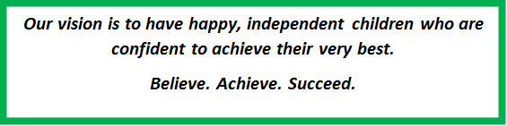
Visible Consistencies
- Meet and greet every child with a smile each day
- Recognition boards in every classroom
- Restorative approaches to behavioural concerns or conflict
- ‘Wonderful walking’ around the school
- Manners matter
- Uniform matters
- Relentless Routines
Rewards
- Verbal and non verbal praise
- Work displayed in class/corridors
- Stickers in weekly ‘values’ assembly
- Bawtry Mayflower Star stickers
- Postcards home
- Headteacher awards
Consequences
- A non-verbal reminder.
- A quiet verbal reminder.
- 30 second private conversation (using microscript).
- Time out within class (moved places).
- Time out for the child in their own time. Reflective think sheet completed with an adult and restorative conversation held using the meeting prompts. Incident recorded on CPOMS.
- Informal contact with parents where appropriate.
- Refer to SLT/Learning mentor as appropriate.
- Formal contact with parents and child placed on a behaviour support plan if appropriate.
- Follow LA exclusion procedures if necessary.
In the rare case of a serious incident a child may be directly referred to SLT (step 7).
Scripts
30 Second Conversation
- I’ve noticed that (you are not ready to learn/having trouble getting started/wandering around the classroom).
- This means that you are breaking our rule of (Be ready/Be safe/Be respectful).
- You have chosen to do this as you are in charge of your behaviour.
- Do you remember earlier/last week when … (example of positive behaviour).
- This is the (name the behaviour) that I need to see. I know you can do better than this.
- I care about you and know you can make the right choice.
- Thank you for listening.
Restorative Conversation
- What happened?
- What were your thoughts at the time?
- What have you thought since?
- Who has been affected? How?
- What should we do to put things right?
- How can we do things differently in the future?
For younger children, only use three of the questions focussing on what happened, who was affected and how we can put this right.
Appendix 2 – KS2 Reflective Think Sheet
Bawtry Mayflower Primary School
Reflective Think Sheet

What happened? (circle the correct pictures)
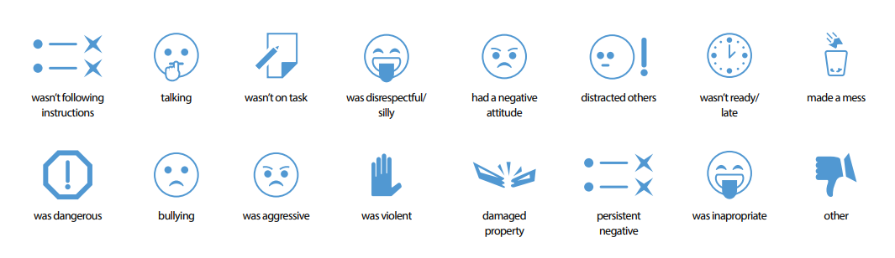
Tell us more

How were you feeling?
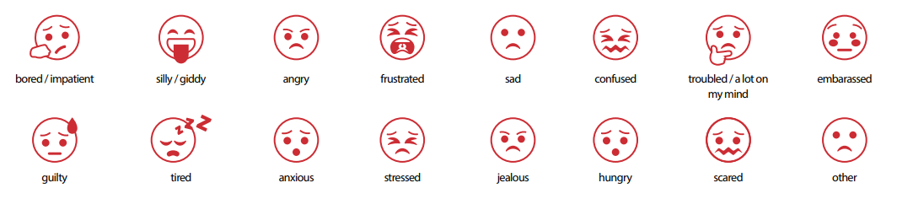
What were you thinking?

Who else has been affected?

How might they be feeling?
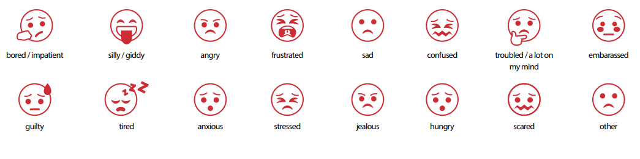
What could you have done differently?

How can we make things better?

Appendix 3 – FS/KS1 Reflective Think Sheet
Bawtry Mayflower Primary School
Reflective Think Sheet

What happened?
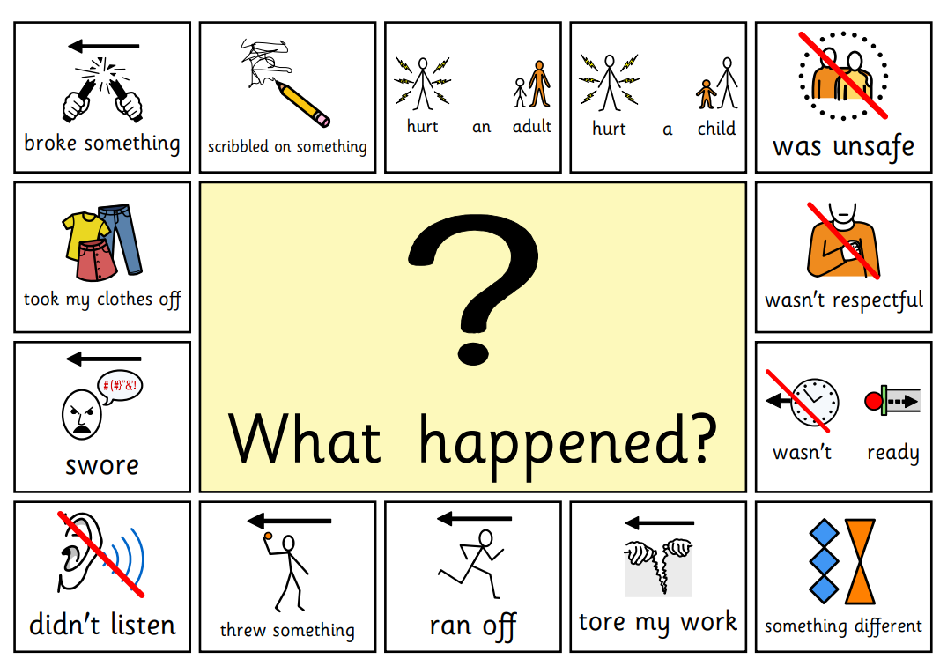
What were you thinking?
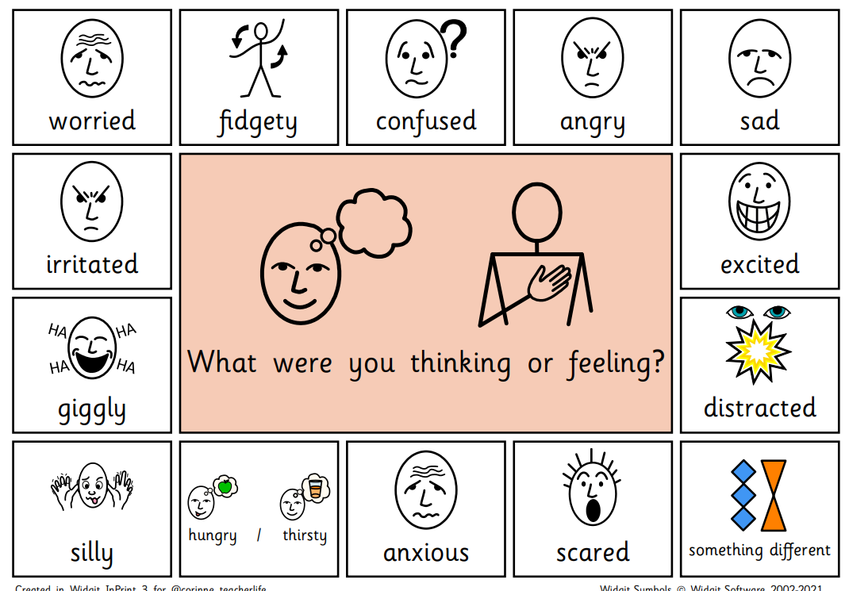

Who has been affected?
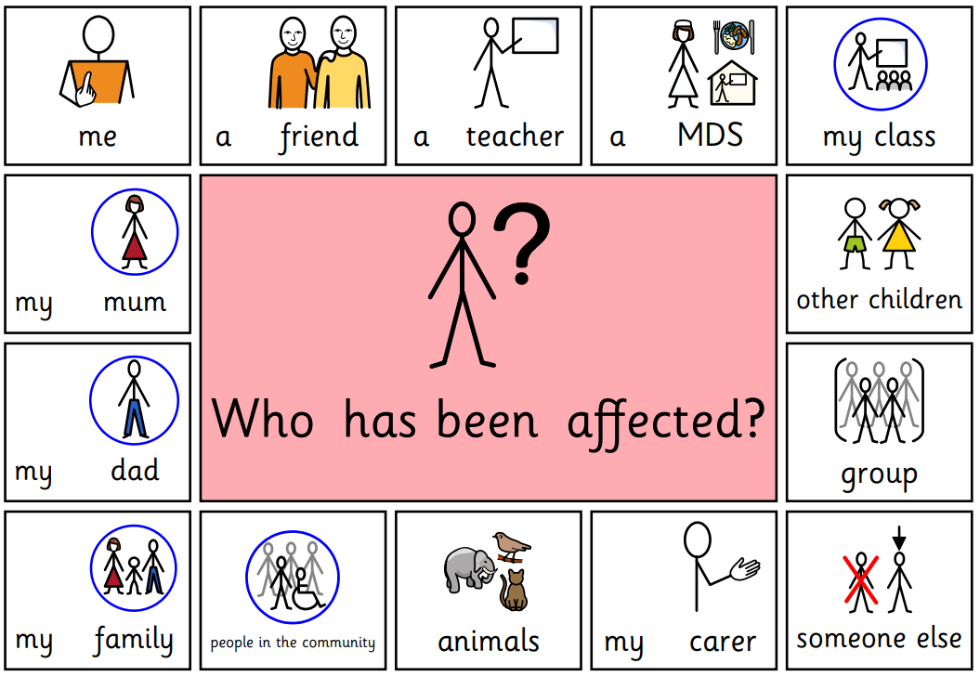
What needs to happen to put it right?
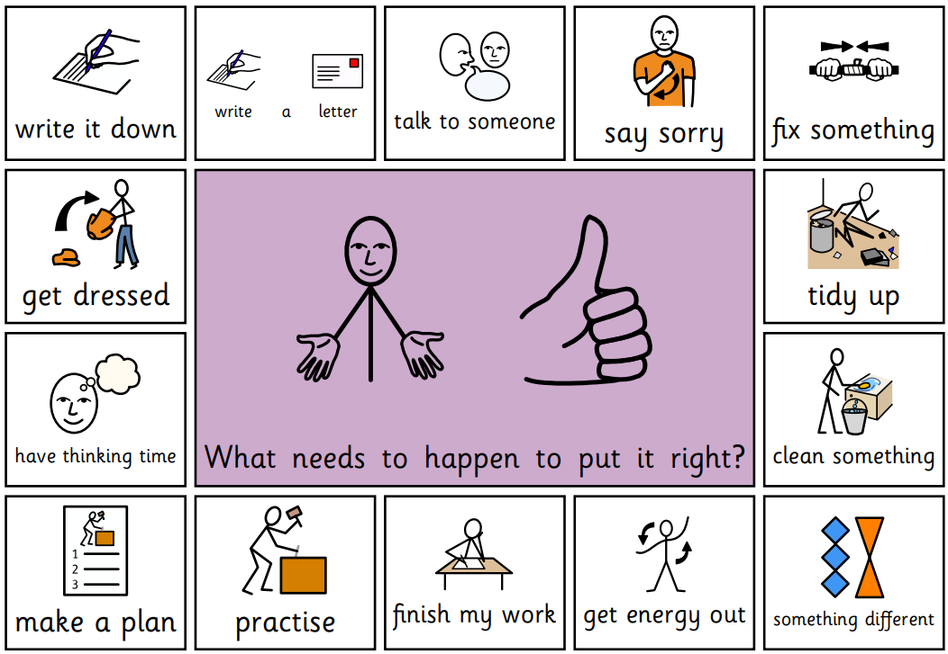
Appendix 4 – Behaviour Plan
Positive Behaviour Support Plan
Name of child: | Start date of plan:
Behaviour we want to change:
Identified Triggers |  |  |  |  | Identified Warning Signs
Function of the behaviour:
Escape ☐ Tangible ☐ Sensory ☐ Attention ☐

Primary Prevention Strategies – Green to be happy and calm
1. Strategies to eliminate or reduce triggers
2. Strategies to replace the behaviour to achieve the same outcome
3. How you will reward positive behaviour

Secondary Prevention Strategies and also to use following crisis – Amber for reducing anxiety

Non-restrictive Reactive strategies - Red for keeping the child and others safe

Outcome you are hoping for (Consider how much you would like to reduce or eliminate the behaviour)
People who have contributed and agreed this plan (Parent/carers and/or other professionals)
How often you review this plan

Review Record
Date | Has the behaviour reduced in line with your planned outcome? Yes/No | Is the review in response to an incident?  Yes/No | What adjustment have you made to the plan? | Name of person reviewing

