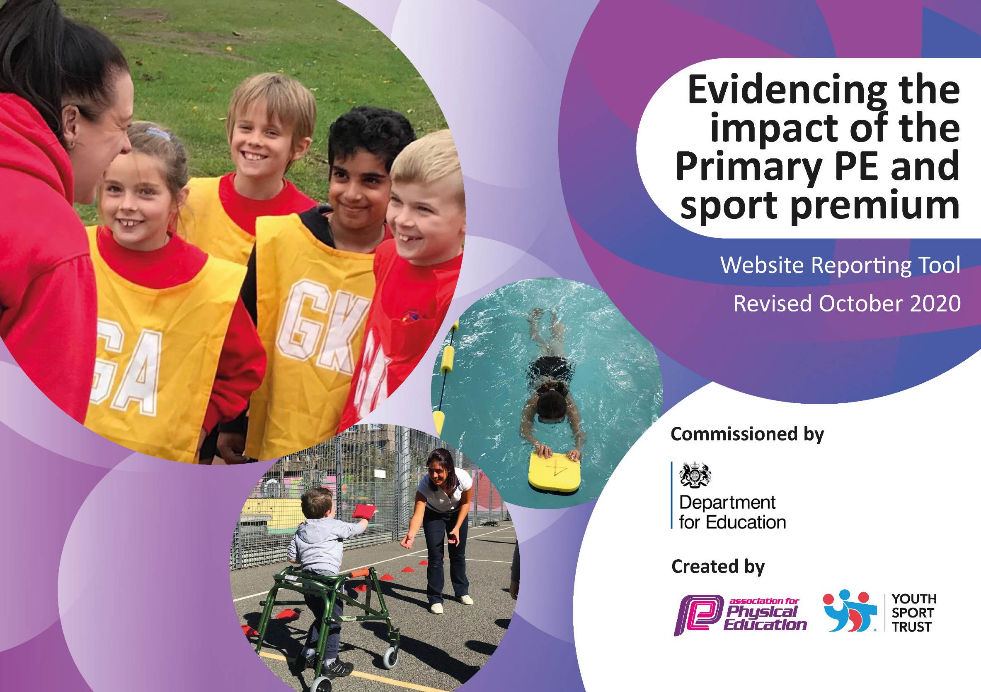

2022-23

Schools must use the funding to make **additional and sustainable** improvements to the quality of PE and sport they offer. This means that you should use the Primary PE and Sport Premium to:

* develop or add to the PE and sport activities that your school already offers
* 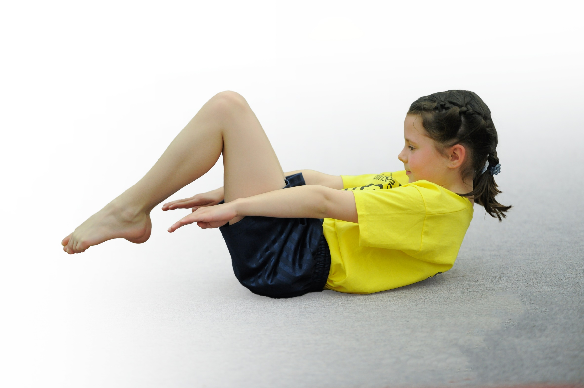build capacity and capability within the school to ensure that improvements made now will benefit pupils joining the school in future years

Please visit [gov.uk](https://www.gov.uk/guidance/pe-and-sport-premium-for-primary-schools) for the revised DfE guidance including the 5 key indicators across which schools should demonstrate an improvement. This document will help you to review your provision and to report your spend. DfE encourages schools to use this template as an effective way of meeting the reporting requirements of the Primary PE and Sport Premium.

We recommend you start by reflecting on the impact of current provision and reviewing the previous spend.

Under the [Ofsted Schools Inspection Framework](https://www.gov.uk/government/publications/school-inspection-handbook-from-september-2015), inspectors will assess how effectively leaders use

the Primary PE and Sport Premium and measure its impact on outcomes for pupils, and how effectively [governors](https://www.gov.uk/government/publications/governance-handbook) hold them to account

for this.

Schools are required to [publish details](https://www.gov.uk/guidance/what-maintained-schools-must-publish-online#pe-and-sport-premium-for-primary-schools) of how they spend this funding as well as on the impact it has on pupils’ PE

and sport participation and attainment.

We recommend regularly updating the table and

publishing it on your website as evidence

of your ongoing review into how you are using the money

to secure maximum, sustainable impact. To see an example of how to complete the table please click HERE.

**Action Plan and Budget Tracking**

Capture your intended annual spend against the 5 key indicators. Clarify the success criteria and evidence of impact that you intend to measure to evaluate for students today and for the future.

|  |  |  |  |  |
| --- | --- | --- | --- | --- |
| **Academic Year:** 2022 - 2023 | **Total fund allocated:** £18,240 | | |  |
| **Key indicator 1:** The engagement of all pupils in regular physical activity – Chief Medical Officers guidelines recommend that primary school pupils undertake at least 30 minutes of physical activity a day in school | | | | Percentage of total allocation: |
| % |
| Intent | Implementation | Funding allocated: | Impact | Sustainability and suggested next steps: |
| Make use of the new ninja warrior course equipment during break times to encourage and improves children’s activity levels therefore improving mental wellbeing.  Make full use of orienteering kit purchased last year.  Encouraging outdoor learning that can be linked to all core subjects, phonics ect.  Improve children’s activity levels to and from school  Further promote physical activity at break times and lunch times.  Re introduce the daily mile in all classes to encourage children’s activity levels | * Have lunch time staff to patrol the ninja warrior area * Have the kit implemented by LC and explained to all staff in order for quality implementation * Look to research and invest in proven schemes that reward children for travelling to and from school in an active way. School competition through local schools new initiative. * Use outdoor spaces to promote outdoor play, and staff given training and resources to engage pupils in play based activity. * A daily 15 minutes of self-paced outdoor activity offering a brain break | N/A  Previous school year | Children to use ninja warrior to increase physical activity, outdoor learning and dedicating time for mental health.  Still waiting for the orienteering kit to be put into place ready for use. Will be up for Summer 2.  Balance bikes in Foundation stage to encourage children biking to school.  Active learning has been a focus especially in KS1. Encouraging and promoting outdoor learning throughout the curriculum.  Children involves in buddies and Active Ambassadors during lunch breaks with older children.  Outdoor learning/active learning outdoors to encourage children to connect with nature and have a brain break. |  |
| **Key indicator 2:** The profile of PESSPA being raised across the school as a tool for whole school improvement | | | | Percentage of total allocation: |
| % |
| Intent | Implementation | Funding allocated: | Impact | Sustainability and suggested next steps: |
| Kick starting the ‘active ambassadors’ roles for the new year.  Giving children the responsibility of running old fashioned playground games during break and lunch times with the younger year groups to encourage active play.  Class celebration assembly every half term to ensure the whole school is aware of the importance of PE and Sport and to encourage all pupils to aspire to being involved in the assemblies.  Raise the profile of PE and Sport for all visitors and parents through parent workshops.  Raising profile through social media ie, twitter and the blog.  Role models – local sporting personalities to attend assemblies / put on events so that pupils can identify with success and aspire to be a local sporting hero. | * Active ambassador’s assembly to happen next week to introduce concept. * Children to have training in the new year of how to implement active play with the younger year groups. * Achievements celebrated in assemblies. * Different classes to do different sporting displays. * Outside/inside school sporting achievements to be reported weekly on the newsletter / on the blog. * Posts on social media * Ascertain with local personalities the pupils relate to and invite them into school. * Invite athletes into school – linked to world events, e.g. Olympics, world cup. * Purchase non-fiction books about sporting heroes and women in sport. | £Free  £ | Through School Games Hannah and Craig completed training to a group of 13 children who then became schools active ambassadors.  Promoting physical activity through old fashioned games and activities at break times.    PE and competitions celebrated through schools stars of the week and given special mentions in Friday celebration assembly’s to showcase the skills used. ie teamwork, sportsmanship.  Schools blog has been refreshed and updated.  School’s twitter is now running and celebrating PE lessons and learning alongside celebrating competitions and teams.  Hannah Cain is a professional footballer who plays as a forward for Leicester City in the FA Women's Super League cam into school following International Women’s day and spoke to the children about following their dream having determination and drive to succeed. |  |

|  |  |  |  |  |
| --- | --- | --- | --- | --- |
| **Key indicator 3:** Increased confidence, knowledge and skills of all staff in teaching PE and sport | | | | Percentage of total allocation: |
| % |
| Intent | Implementation | Funding allocated: | Impact | Sustainability and suggested  next steps: |
| Training and CPD for the subject lead who can then deliver in house CPD to build confidence, knowledge and enthusiasm in staff.  Explore CPD opportunities including online learning.  Invest in CPD that aims to encourage staff motivation as well as their relationship with physical education and sport, rather than just simply up-skilling staff in the technical aspects of traditional sporting activities. | * CPD training for LC * Quality first teaching- Linked to physical education delivery, whole school physical activity learning strategies and/or outdoor learning initiatives. | £  £ | Cre8tive Dance CPD and tem teaching for staff to build confidence in gymnastics and dance.  Following feedback from staff- Street dance CPD in March following this feedback.  Bought into the Your PE scheme having seen this in action at Sunnyfields Primary through the PE Governor.  Owen has been into school and discussed the scheme in detail with PE lead and is running a whole school training in June.  Effective precise scheme that showcases progression throughout the key stages. |  |
| **Key indicator 4:** Broader experience of a range of sports and activities offered to all pupils | | | | Percentage of total allocation: |
| % |
| Intent | Implementation | Funding allocated: | Impact | Sustainability and suggested  next steps: |
| Children to attend competitions through active fusion to broaden experiences and offer children local community competitions with other nearby schools.  Experience days and visits to have exposure to a wider spectrum of sports.  Look at afterschool club opportunities for more obscurer sports | * Children to attend local competitions through active fusion. * For example kin ball team in to discuss and sample kin ball game * Have opportunities for children to attend obscurer sports sessions moving away from the national curriculum sports. | £50 to School games  Coach trips in total to date: | Competitions running positively throughout school and year groups.  Children attending other schools and taking part.  Children to attend Stoneacre cup tournament at Keep Moat stadium.  Currently running dodgeball club after school club. |  |
| **Key indicator 5:** Increased participation in competitive sport | | | | Percentage of total allocation: |
| % |
| Intent | Implementation | Funding allocated: | Impact | Sustainability and suggested  next steps: |
| Children to attend competitions through active fusion to broaden experiences and offer children local community competitions with other nearby schools.  Provide regular opportunities for intra and inter school competition.  Regular opportunities in PE lessons for children to compete against one another.  Through assemblies and motivational PE speakers motivate and excite children to want to compete. | * Arrange friendly competition – inter / intra school * Attend school games competitions * Through the use of the new PE curriculum map across years 1-6. Ensuring challenge and competitions between the children is available and encouraged. * Motivational speakers to ignite interest into PE learning and participation. | £ | Competitions attended throughout school year for all year groups.  Through the Your PE scheme completing inter school mini competitions.  Incorporating Bawtry Juniors football club to train with a female team ready for a competitions in July.  Hannah Cain in to support women in sport and opportunity for girls through football.  Kidz fir coach in school for wellbeing week  Coach Vinnie tennis coach wellbeing week. |  |

|  |  |  |  |  |
| --- | --- | --- | --- | --- |
| **Key indicator 6:** Ensure the effective delivery of teaching and learning in Physical Education | | | | Percentage of total allocation: |
| % |
| Intent | Implementation | Funding allocated: | Impact | Sustainability and suggested  next steps: |
| Monitor engagement of all children including SEND and PP.  Training and CPD for the subject lead who can then deliver in house CPD to build confidence, knowledge and enthusiasm in staff.  Explore CPD opportunities including online learning.  Invest in CPD that aims to encourage staff motivation as well as their relationship with physical education and sport, rather than just simply up-skilling staff in the technical aspects of traditional sporting activities. | * Work closely with PP lead to monitor impact of PE on PP and SEND children to survey effectiveness of outdoor learning with SEND targets. * LC to attend training on QFT to then redeliver to teaching staff during in house CPD sessions. * CPD training for a member of staff in each key phases to ensure that the majority of the team will have somebody to collaborate with during delivery and teaching. |  | New scheme has specifically targeted STEP and how to differentiate for all needs of pupils.  Tracking and assessment tool can highlight PP children so assessment can take place.  LC attended CPD and training including Youth Sport Trust conference.  Cre8tive CPD sessions  Team-teaching with staff for internal CPD. |  |
| **Key indicator 7:** Increased health and well-being of our children with the understanding that a healthy mind = a healthy body. | | | | Percentage of total allocation: |
| % |
| Intent | Implementation | Funding allocated: | Impact | Sustainability and suggested  next steps: |
| Increased understanding of the importance of health and wellbeing and how this can have a positive impact on our pupils’ learning.  Have focuses on mental health and wellbeing through daily mile, more outdoor learning for brain breaks and stress reducers. | * Through whole school initiative in promoting healthy living and lifestyles * QFT ensuring that all PE lessons have links to the physical impacts PE have on your bodies. * Daily mile initiative introduced through school | £ | Wellbeing week established in school which will repeat annually.  Kidz fit coach in to discuss importance of having a healthy body, mind ect.  Vinnie Tennis coach ran tennis sessions throughout school  Carousel wellbeing activities throughout school.  Displays containing links to mental health and physical health around school to promote and concrete benefits.  Pe links to head hand and heart discussed throughout school PE lessons through PE scheme initiative. |  |